# Visvesvaraya Technological University Belagavi-590 018, Karnataka



A Mini Project Report on

# “COURIER MANAGEMENT SYSTEM”

**Mini Project Report submitted in partial fulfillment of the requirement for the DBMS Laboratory with Mini Project [18CSL58]**

# Bachelor of Engineering

**in**

# Computer Science and Engineering

## Submitted by

**Surya N. B. - [1JT20CS103]**



# Department of Computer Science and Engineering Jyothy Institute of Technology Tataguni, Bengaluru-560082

**Jyothy Institute of Technology Tataguni, Bengaluru-560082**

# Department of Computer Science and Engineering



**CERTIFICATE**

Certified that the mini project work entitled **“COURIER MANAGEMENT SYSTEM”** carried out by **Surya N. B. [1JT20CS103]** bonafide students of Jyothy Institute of Technology, in partial fulfilment for the award of **Bachelor of Engineering** in **Computer Science and Engineering** department of the **Visvesvaraya Technological University, Belagavi** during the year **2022-2023**. It is certified that all corrections/suggestions indicated for Internal Assessment have been incorporated in the Report deposited in the departmental library. The project report has been approved as it satisfies the academic requirements in respect of Project work prescribed for the said Degree.

Mrs. Sunitha B. Dr. Prabhanjan S.

Guide, Asst. Professor Professor & HOD

Dept. of CSE Dept. of CSE

External Viva Examiner Signature with Date: 1.

2.

# ACKNOWLEDGEMENT

Firstly, I am very grateful to this esteemed institution **“Jyothy Institute of Technology**” for providing me an opportunity to complete our project.

I express my sincere thanks to our **Principal Dr. Gopalakrishna K** for providing me with adequate facilities to undertake this project.

I would like to thank **Dr. Prabhanjan S., Professor and Head of Computer**

**Science and Engineering** Department for providing his valuable support.

I would like to thank our guides **Mrs. Sunitha B., Assistant Professor**

for their keen interest and guidance in preparing this work.

Finally, I would thank all our friends who have helped us directly or indirectly in this project.

**Surya N. B. [1JT20CS103]**

# ABSTRACT

This **Courier Management System** Project will have different modules. The login section will have login facility for the admin and for the user who will operate this system.

While taking orders from its customers, it will take all the details of its customers who is placing the orders and all the details for the recipient such as its address, name and mobile number.

Through the tracking id, customers or its recipient will able to track their products from any location using internet. It will provide status of the product after placing orders within 1 minute.

The admin can manipulate the data through admin login page and add any new consignment if required. The profile section shows the data of the user and the ricing section of the project shows the price that will be charged for the consignment according to the weight categories.

Using the courier service person can easily send his/her parcel to other person in the particular destination within the time

# TABLE OF CONTENTS

|  |  |
| --- | --- |
| **SL No** | **Description** |
| 1 | INTRODUCTION |
| 2 | DESIGN |
| 3 | IMPLEMENTATION |
| 4 | SNAPSHOTS |
| 5 | CONCLUSION, FEATURES,  REQUIREMENTS & REFERENCES |

## CHAPTER 1:

**INTRODUCTION**

* 1. **Introduction to DBMS**

A database is simply an organized collection of related data, typically stored on disk, and accessible by many concurrent users, it is a logically coherent collection of data with some inherent meaning, representing some aspect of real world and which is designed, built and populated with data for a specific purpose.

Databases are managed by a Database Management System (DBMS) which is a collection of programs that enables user to create and maintain a database.

Advantages of DBMS:

* Redundancy is controlled.
* Unauthorized access is restricted.
* Providing multiple user interfaces.
* Enforcing integrity constraints.
* Providing backup and recovery.

## Introduction to SQL

Structured Query Language (SQL), is a language used to request data from a database which includes database creation, deletion, and retrieval of required tables and even manipulation of data held in a relational database management system.

SQL is considered as a Non-Procedural or a High level language in which the expected result or operation is given without the specific details about how to accomplish the task. So, SQL is a declarative language.

Therefore, SQL is designed at a higher conceptual level of operation than procedural languages as procedural languages includes only the information about opening and closing tables, loading and searching indexes, or flushing buffers and writing data to file systems, but the lower level logical and physical operations are not specified in SQL.

**1.3 Introduction to Courier Management System**

This Courier Management System Project will have different modules. The login section will have login facility for the admin and for the user who will operate this system.

While taking orders from its customers, it will take all the details of its customer who is placing the order and all the details for the recipient such as its address, name and mobile number.

During billing process system will generate a tracking id for their products. Through this tracking id, customers or its recipient will able to track their products from any location using internet. It will provide status of the product after placing orders within 1 minute.

The courier service is one of the solutions of these problems. It is used to send things to any person in the country within a certain time. The courier company has number of branches, which are spread over the country or the world. So that when person wants to send things then he has to contact at nearest courier service branch. The courier company creates the schedule & gives internal/external services. The courier service work as destination office or source office.

In modern age, as time increase, needs & requirements of the person are also increased. They want more facility & try to do their task quickly & within time. But they cannot get all the things at nearest market or area, so they have to import the things from any place in the world.

Within the country, the things can be imported through post service. But it consumes the time & sometimes problem of damage or missing occur. Where as in the international market, the one way is shipping. But it also requires more time.

**CHAPTER 2*:***

# DESIGN

## 2.1 Theory of ER Diagram

The Entity–Relationship model (ER model) describes the structure of a database with the help of a diagram, which is known as **Entity Relationship Diagram (ER Diagram)**

An **Entity Relationship Diagram (ERD)** shows the relationships of entity sets stored in a database. An entity in this context is an object, a component of data.

An entity set is a collection of similar entities. These entities can have attributes that define its properties. By defining the entities, their attributes, and showing the relationships between them, an ER diagram illustrates the logical structure of database.

ER diagrams are used to sketch out the design of a database.

## 2.2 Entities

An entity is an 'object' in the real world with an independent existence and an entity type defines a collection (or set) of entities that have the same attributes. Each entity type in the database is described by its name and attributes.

An entity type is represented in ER diagrams as a rectangular box enclosing the entity type name.

## 2.3 Relationships

A relationship among two or more entities represents an association among the entities and whenever an attribute of one entity refers to another entity, there exists a relationship between the two entities.

In a relationship, a foreign key of one table refers the primary key of the other table and it is represented by diamond shape in ER diagram.

## 2.4 Attributes

An attribute represents some property of interest that further describes an entity and the column header of the table shows the attributes. Each attribute in a table has a certain domain which allows it to accept a certain ‘set of values’ only.

The attribute values, of each entity, will define its characteristics in the table and is represented by oval in the ER diagram.

**ER DIAGRAM**

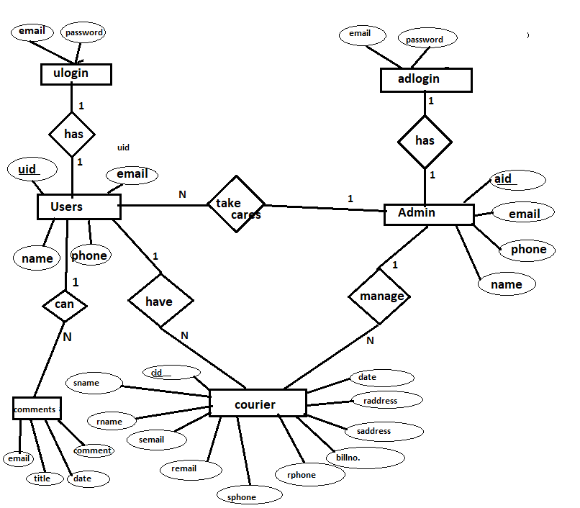

**SCHEMA DIAGRAM**

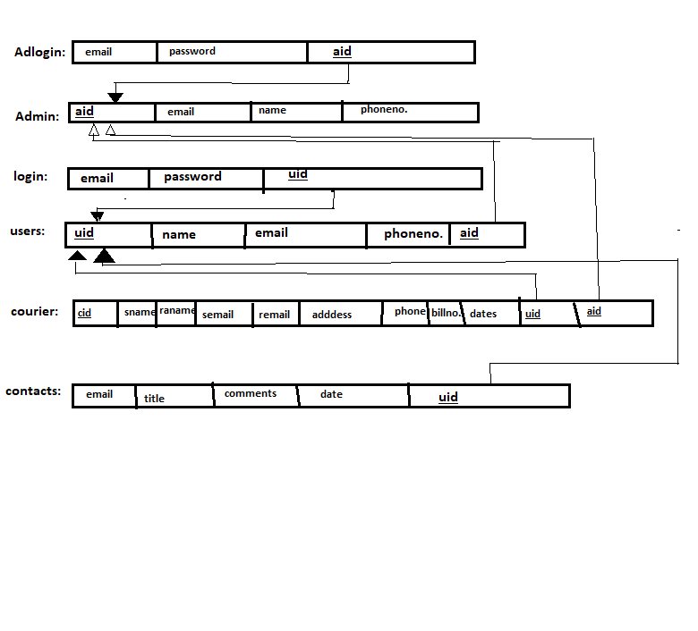

**CHAPTER 3:**

# IMPLEMENTATION

INDEX.PHP:

<?php

require_once "dbconnection.php";

require_once "session.php";

if ($_SERVER["REQUEST_METHOD"] == "POST" && isset($_POST['submit'])) {

    $email = $_POST['email'];

    $password = $_POST['password'];

    $qry = "SELECT * FROM `login` WHERE `email`='$email' AND `password`='$password'";

    $run = mysqli_query($dbcon, $qry);

    $row = mysqli_num_rows($run);

    if ($row < 1) {

?>

        <script>

            alert("Oops! Please enter your Username and Password again!");

            window.open('index.php', '_self');

        </script> <?php

                } else {

                    $data = mysqli_fetch_assoc($run);

                    $id = $data['u_id'];    //fetch id value of user

                    $email = $data['email'];

                    $_SESSION['uid'] = $id;

                    $_SESSION['emm'] = $email;

                    ?>

        <script>

            alert("Welcome!");

            window.open('home/home.php', '_self');

        </script> <?php

                }

            }

?>

<!DOCTYPE html>

<html lang="en">

<head>

    <meta charset="UTF-8">

    <meta name="viewport" content="width=device-width, initial-scale=1.0">

    <title>Login</title>

    <link rel="stylesheet" href="https://stackpath.bootstrapcdn.com/bootstrap/4.4.1/css/bootstrap.min.css">

    <style>

        body {

            background-image: url('images/dd1.jpg');

            background-repeat: no-repeat;

            background-size: cover;

        }

    </style>

</head>

<body>

    <h1 align='center' style="margin: 15px; color:white;font-weight: bold;font-family:'Times New Roman', Times, serif">RAPID COURIER SERVICE</h1>

    <hr />

    <P align='center' style="font-weight: bold;color:orange;font-family:'Times New Roman', Times, serif">IN SPEED WE TRUST.</P>

    <div>

        <h5><a href="admin/adminlogin.php" style="float: right; margin-right:40px; color:white; margin-top:0px">Admin Login</a></h5>

    </div>

    <div class="container" style="margin-top: 60px; width:50%;">

        <div class="row">

            <div class="col-md-12">

                <h2 style="color: #ffffff;">Login</h2>

                <p style="color:#ffffff;">Please fill in your credentials ⮯⮯</p>

                <!-- <?php echo $error; ?> -->

                <form action="" method="post">

                    <div class="form-group">

                        <label style="color:#ffffff;">Email Address</label>

                        <input type="email" name="email" class="form-control" placeholder="Enter username/emailId" required />

                    </div>

                    <div class="form-group">

                        <label style="color:#ffffff;">Password</label>

                        <input type="password" name="password" class="form-control" placeholder="Enter your password" required>

                    </div>

                    <div class="form-group">

                        <input type="submit" name="submit" class="btn btn-primary" value="Sign In" />

                        <button onclick="window.location.href='resetpswd.php'" class="btn btn-danger" style="cursor:pointer">Reset Password</button>

                    </div>

                    <p style="color: #e84118;">Don't have an account?⮞➤ <a href="register.php">Register here</a>.</p>

                </form>

            </div>

        </div>

    </div>

</body>

</html>

DBCONNECTION.PHP:

<?php

    $dbcon = mysqli_connect('localhost','root','','courierdb');

    if($dbcon==false)

    {

        echo "Database is not Connected!";

    }

?>

HOME.PHP:

<?php

session_start();

if(isset($_SESSION['uid'])){

    echo "";

    }else{

    header('location: ../index.php');

    }

?>

<!DOCTYPE html>

<html lang="en">

<head>

    <meta charset="UTF-8">

    <meta name="viewport" content="width=device-width, initial-scale=1.0">

    <title>Home Page</title>

    <style>

        body

        {

        background-image:url('../images/delivery.jpg');

        background-repeat: no-repeat;

        background-size: cover;

        }

    </style>

</head>

<body>

    <?php include('header.php'); ?>

    <div align='center' style="font-weight: bold;font-family:'Times New Roman', Times, serif"><br><br><br><br>

        <h2 style="color:black;"><b>THIS IS RAPID COURIER MANAGEMENT SERVICE</b></h2>

        <h4><b>IN SPEED WE TRUST</b></h4><br><br>

        <h3><b><marquee>The go-to website for courier delivery!</marquee></b></h3>

    </div>

</body>

</html>

COURIERMENU.PHP:

<!-- for 'courier' navbar, courier placing page -->

<?php

session_start();

if (isset($_SESSION['uid'])) {

    echo "";

} else {

    header('location: ../index.php');

}

?>

<?php

include('header.php');

$email = $_SESSION['emm'];

$uid = $_SESSION['uid'];

?>

<!DOCTYPE html>

<html lang="en">

<head>

    <meta charset="UTF-8">

    <meta name="viewport" content="width=device-width, initial-scale=1.0">

    <title>Place Order</title>

    <style>

        body {

            background-image: url('../images/delivery.jpg');

            background-repeat: no-repeat;

            background-size: cover;

        }

    </style>

</head>

<body>

    <form action="courierMenu.php" method="POST" enctype="multipart/form-data">

        <div style="overflow-x:auto;">

            <table border="0px solid" style="margin: auto; font-weight:bold;border-spacing: 5px 15px;">

                <th colspan="4" style="text-align: center;background-color:#add8e6; width: 140px; height: 50px;">Fill the details of sender & receiver</th>

                <tr>

                    <td colspan="4" style="text-align: center;">

                        <hr>

                    </td>

                </tr>

                <tr style="text-align: center;">

                    <th colspan="2">SENDER</th>

                    <th colspan="2">RECEIVER</th>

                </tr>

                <tr>

                    <td colspan="4">

                        <hr>

                    </td>

                </tr>

                <tr>

                    <th colspan="2"></th>

                    <th colspan="2"></th>

                </tr>

                <tr>

                    <td>Name:</td>

                    <td><input type="text" name="sname" placeholder="Sender FullName" required></td>

                    <td>Name:</td>

                    <td><input type="text" name="rname" placeholder="Sender FullName" required></td>

                </tr>

                <tr>

                    <td>Email:</td>

                    <td><input type="text" name="semail" value="<?php echo $email; ?>" readonly></td>

                    <td>Email:</td>

                    <td><input type="text" name="remail" placeholder="Receiver EmailId" required></td>

                </tr>

                <tr>

                    <td>PhoneNo.:</td>

                    <td><input type="number" name="sphone" placeholder="sender number" required></td>

                    <td>PhoneNo.:</td>

                    <td><input type="number" name="rphone" placeholder="receiver number" required></td>

                </tr>

                <tr>

                    <td>Address:</td>

                    <td><input type="textfield" name="saddress" placeholder="sender address" required></td>

                    <td>Address:</td>

                    <td><input type="textfield" name="raddress" placeholder="receiver address" required></td>

                </tr>

                <tr>

                    <td colspan="4">✖️✖️✖️✖️✖️✖️✖️✖️✖️✖️✖️✖️✖️✖️✖️✖️✖️✖️✖️✖️✖️✖️✖️✖️✖️✖️✖️✖️✖️✖️✖️</td>

                </tr>

                <tr>

                    <td>Weight:</td>

                    <td><input type="number" name="wgt" placeholder="weights in kg" required></td>

                    <td>Payment Id:</td>

                    <td><input type="number" name="billno" placeholder="enter transition num" required></td>

                </tr>

                <tr>

                    <!-- <td>Date:</td><td><input type="date" name="date"></td> -->

                    <td>Date:</td>

                    <td><input type="date" name="date" value="<?php echo date('Y-m-d'); ?>" readonly /></td>

                    <td>Items Image:</td>

                    <td><input type="file" name="simg" ></td>

                </tr>

                <tr>

                    <td colspan="4" align="center"><input type="submit" name="submit" value="Place Order" style="background-color: orange; border-radius: 15px; width: 140px; height: 50px;cursor:pointer;"></td>

                </tr>

            </table>

        </div>

    </form>

</body>

</html>

<?php

if (isset($_POST['submit'])) {

    include('../dbconnection.php');

    $sname = $_POST['sname'];

    $rname = $_POST['rname'];

    $semail = $_POST['semail'];

    $remail = $_POST['remail'];

    $sphone = $_POST['sphone'];

    $rphone = $_POST['rphone'];

    $sadd = $_POST['saddress'];

    $radd = $_POST['raddress'];

    $wgt = $_POST['wgt'];

    $billn = $_POST['billno'];

    $originalDate = $_POST['date'];

    $newDate = date("Y-m-d", strtotime($originalDate));

    $imagenam = $_FILES['simg']['name'];

    $tempnam = $_FILES['simg']['tmp_name'];

    move_uploaded_file($tempnam, "../dbimages/$imagenam");

    $qry = "INSERT INTO `courier` (`sname`, `rname`, `semail`, `remail`, `sphone`, `rphone`, `saddress`, `raddress`, `weight`, `billno`, `image`,`date`,`u_id`) VALUES ('$sname', '$rname', '$semail', '$remail', '$sphone', '$rphone', '$sadd', '$radd', '$wgt', '$billn', '$imagenam', '$newDate','$uid');";

    $run = mysqli_query($dbcon, $qry);

    if ($run == true) {

    ?> <script>

            alert('Order Placed Successfully :)');

            window.open('courierMenu.php', '_self');

        </script>

    <?php

    }

}

?>

TRACKMENU.PHP:

<!-- when track menu is clicked it will show all courier placed by that User-->

<?php

session_start();

if(isset($_SESSION['uid'])){

    echo "";

    }else{

    header('location: ../login.php');

    }

?>

<?php include('header.php'); ?>

<div style="overflow-x:auto;">

<table width='80%' border="1px dash" style="margin-top:30px;margin-left:auto ;margin-right:auto ;font-weight:bold;border-spacing: 5px 5px;border-collapse: collapse;">

    <tr style="background-color: white;font-size:30px">

        <th>No.</th>

        <th>Item's Image</th>

        <th>Sender Name</th>

        <th>Receiver Name</th>

        <th>Receiver Email</th>

        <th>Action</th>

    </tr>

    <?php

    include('../dbconnection.php');

    $email = $_SESSION['emm'];

    $qryy= "SELECT * FROM `courier` WHERE `semail`='$email'";

    $run= mysqli_query($dbcon,$qryy);

    if(mysqli_num_rows($run)<1){

        echo "<tr><td colspan='6'>No record found..</td></tr>";

    }

    else{

        $count=0;

        while($data=mysqli_fetch_assoc($run))

        {

            $count++;

        ?>

        <tr align="center">

            <td><?php echo $count; ?></td>

            <td><img src="../dbimages/<?php echo $data['image']; ?>" alt="pic" style="max-width: 100px;"/> </td>

            <td><?php echo $data['sname']; ?></td>

            <td><?php echo $data['rname']; ?></td>

            <td><?php echo $data['remail']; ?></td>

            <td>

                <a href="updationtable.php?sid=<?php echo $data['c_id']; ?>">Edit</a> ||

                <a href="deletecourier.php?bb=<?php echo $data['billno']; ?>">Delete</a>||

                <a href="status.php?sidd=<?php echo $data['c_id']; ?>">Check status</a>

            </td>

        </tr>

        <?php

        }

    }

    ?></table></div>

ADMINLOGIN.PHP:

<!-- admin logIn page and login logic -->

<?php

session_start();

if (isset($_SESSION['uid'])) {

    header('location: dashboard.php');

}

?>

<!DOCTYPE html>

<html lang="en">

<head>

    <meta charset="UTF-8">

    <meta name="viewport" content="width=device-width, initial-scale=1.0">

    <title>Admin Login</title>

</head>

<body bgcolor="#add8e6">

    <h5><a href="../index.php" style="float: right; margin-right:50px; color:#000000">Back to home</a></h5><br>

    <h1 align='center' style="color: #ffffff;font-size:60px"><b>Admin Login</b></h1>

    <h6 align='center' style="color: #212121;font-weight: bold;font-size:15px">Login as an Admin.</h6>

    <form action="adminlogin.php" method="POST" style="margin: auto;">

        <table align="center">

            <tr>

                <td>Email-ID:</td>

                <td><input type="email" name="uname" require></td>

            </tr>

            <tr><td><br></td></tr>

            <tr>

                <td>Password:</td>

                <td><input type="password" name="pass" require></td>

            </tr>

            <tr>

                <td colspan="2">

                    <hr>

                </td>

            </tr>

            <tr>

                <td colspan="2" align="center"><input type="submit" name="login" value="Login" style="cursor: pointer;"></td>

            </tr>

        </table>

    </form>

</body>

</html>

<?php

include('../dbconnection.php');

if (isset($_POST['login'])) {

    $ademail = $_POST['uname'];

    $password = $_POST['pass'];

    $qry = "SELECT * FROM `adlogin` WHERE `email`='$ademail' AND `password`='$password'";

    $run = mysqli_query($dbcon, $qry);

    $row = mysqli_num_rows($run);

    if ($row < 1) {

        ?>

        <script>

            alert("Only admin can login..");

            window.open('adminlogin.php', '_self');

        </script><?php

    }

    else {

        $data = mysqli_fetch_assoc($run);

        $id = $data['a_id'];

        $_SESSION['uid'] = $id;

        header('location:dashboard.php');

    }

}

?>

DASHBOARD.PHP:

<!-- admin dashbord page with options for admin -->

<?php

session_start();

if(isset($_SESSION['uid'])){

    echo "";

}else{

    header('location: ../login.php');

}

?>

<?php

include('head.php');

?>

<style>

    body {

        background-image: url('../images/10.png');

        background-size: cover;

        }

</style>

<div class="admintitle">

    <div>

    <h5 ><a href="../index.php" style="float: left; margin-left:20px; color:aliceblue;">Login as user</a></h5>

    <h5 ><a href="logout.php" style="float: right; margin-right:20px; color:aliceblue;">Log out</a></h5>

    </div>

    <h1 align='center' style="text-shadow: 0.1em 0.1em 0.15em #f9829b;">Welcome To Admin Dashbord!</h1>

</div>

<div align="center" style="margin-top:240px;">

<form style="position: center;color:lightblue;font-weight:bold;font-size:50px">

    <a href="deletedata.php" style="color:white;">Delete Data</a><br><br>

    <a href="deleteusers.php" style="color:white;">Delete Users</a><br><br>

</form>

</div>

</body>

</html>

STYLE.CSS:

*{

    margin: 0;

    padding: 0;

    background-repeat: no-repeat;

}

.admintitle{

    background-color: brown;

    color: #fff;

    margin-left: 50px;

    margin-right: 50px;

    height: 140px;

    line-height: 140px;

}

/*  style for header  */

.header{

    position: fixed;

    width: 100%;

    height: 80px;

    text-align: center;

    top: 0;

    background-color: #d5d8d8;

}

.header img {

    float: left;

    width: 80px;

    height: auto;

    background: #555;

}

.header h1 {

    position: relative;

    top: 10px;

    text-align: center;

}

body{

    margin:0;

    padding:0;

}

/* style for navbar */

.topnav {

    overflow: hidden;

    background-color: #333;

    margin-top: 80px;

  }

  .topnav a {

    float: left;

    margin-block-end: 10px;

    display: block;

    color: #f2f2f2;

    text-align: center;

    padding: 14px 16px;

    text-decoration: none;

    font-size: 17px;

  }

  .topnav a:hover {

    background-color: #ddd;

    color: black;

  }

  .topnav a.active {

    background-color: #4CAF50;

    color: white;

  }

  .topnav .icon {

    display: none;

  }

  @media screen and (max-width: 600px) {

    .topnav a:not(:first-child) {display: none;}

    .topnav a.icon {

      float: right;

      display: block;

    }

  }

  @media screen and (max-width: 600px) {

    .topnav.responsive {position: relative;}

    .topnav.responsive .icon {

      position: absolute;

      right: 0;

      top: 0;

    }

    .topnav.responsive a {

      float: none;

      display: block;

      text-align: left;

    }

  }

  /* css for contactUs */

  /* custom css styling */

@import url('https://fonts.googleapis.com/css?family=Poppins:400,500,600,700&display=swap');

html,body{

    background: #2b3a49;

}

::selection{

    color: #fff;

    background: #007bff;

}

.container{

    position: absolute;

    top: 50%;

    left: 50%;

    transform: translate(-50%, -50%);

    font-family: 'Poppins', sans-serif;

}

.container .mail-form{

    background: #fff;

    padding: 25px 35px;

    border-radius: 5px;

    box-shadow: 0 4px 8px 0 rgba(0, 0, 0, 0.2),

                0 6px 20px 0 rgba(0, 0, 0, 0.19);

}

.container form .form-control{

    height: 43px;

    font-size: 15px;

}

.container .mail-form form .form-group .button{

    font-size: 17px!important;

}

.container form .textarea{

    height: 100px;

    resize: none;

}

.container .mail-form h2{

    font-size: 30px;

    font-weight: 600;

}

.container .mail-form p{

    font-size: 14px;

}

SQL FILE:

COURIERDB.SQL:

SET SQL_MODE = "NO_AUTO_VALUE_ON_ZERO";

START TRANSACTION;

SET time_zone = "+00:00";

--

-- Database: `courierdb`

--

-- --------------------------------------------------------

--

-- Table structure for table `adlogin`

--

CREATE TABLE `adlogin` (

  `email` varchar(50) DEFAULT NULL,

  `password` varchar(50) DEFAULT NULL,

  `a_id` int(11) DEFAULT NULL

) ENGINE=InnoDB DEFAULT CHARSET=utf8mb4;

--

-- Dumping data for table `adlogin`

--

INSERT INTO `adlogin` (`email`, `password`, `a_id`) VALUES

('admin1@gmail.com', '12345', 1),

('admin2@gmail.com', '12345', 2);

-- --------------------------------------------------------

--

-- Table structure for table `admin`

--

CREATE TABLE `admin` (

  `a_id` int(11) NOT NULL,

  `email` varchar(50) NOT NULL,

  `name` varchar(50) DEFAULT NULL,

  `pnumber` int(14) DEFAULT NULL

) ENGINE=InnoDB DEFAULT CHARSET=utf8mb4;

--

-- Dumping data for table `admin`

--

INSERT INTO `admin` (`a_id`, `email`, `name`, `pnumber`) VALUES

(1, 'admin1@gmail.com', 'Admin1', 12345),

(2, 'admin2@gmail.com', 'Admin2', 12345);

-- --------------------------------------------------------

--

-- Table structure for table `contacts`

--

CREATE TABLE `contacts` (

  `id` int(11) NOT NULL,

  `email` varchar(50) NOT NULL,

  `subject` varchar(30) NOT NULL,

  `msg` varchar(300) NOT NULL

) ENGINE=InnoDB DEFAULT CHARSET=utf8mb4;

--

-- Dumping data for table `contacts`

--

INSERT INTO `contacts` (`id`, `email`, `subject`, `msg`) VALUES

(1, 'love@gmail.com', 'delay', 'I have courier 2 weeks ago but its not delivered yet..'),

(2, 'labh.18is033@cambridge.edu.in', 'Delay', 'gjndfjkgnhdfjkgn');

-- --------------------------------------------------------

--

-- Table structure for table `courier`

--

CREATE TABLE `courier` (

  `c_id` int(11) NOT NULL,

  `u_id` int(11) DEFAULT NULL,

  `semail` varchar(50) DEFAULT NULL,

  `remail` varchar(50) DEFAULT NULL,

  `sname` varchar(50) DEFAULT NULL,

  `rname` varchar(50) DEFAULT NULL,

  `sphone` varchar(20) DEFAULT NULL,

  `rphone` varchar(20) DEFAULT NULL,

  `saddress` varchar(50) DEFAULT NULL,

  `raddress` varchar(50) DEFAULT NULL,

  `weight` int(11) DEFAULT NULL,

  `billno` int(11) NOT NULL,

  `image` text DEFAULT NULL,

  `date` date NOT NULL

) ENGINE=InnoDB DEFAULT CHARSET=utf8mb4;

--

-- Dumping data for table `courier`

--

INSERT INTO `courier` (`c_id`, `u_id`, `semail`, `remail`, `sname`, `rname`, `sphone`, `rphone`, `saddress`, `raddress`, `weight`, `billno`, `image`, `date`) VALUES

(7, 4, 'love@gmail.com', 'himanshu@gmail.com', 'love', 'himanshu', '06362786223', '6526652', 'KR puram,Bangalore,Karnataka', 'Boys hostel of Cambridge institute of technology,j', 2, 22, 'cddd.jpeg', '2020-12-06'),

(8, 4, 'love@gmail.com', 'gyanshu@gmail.com', 'love', 'gyanshu', '06362786223', '06362786223', 'KR puram,Bangalore,Karnataka', 'Boys hostel of Cambridge institute of technology,j', 2, 3263, 'fc.png', '2020-12-06');

-- --------------------------------------------------------

--

-- Table structure for table `login`

--

CREATE TABLE `login` (

  `email` varchar(50) DEFAULT NULL,

  `password` varchar(50) DEFAULT NULL,

  `u_id` int(11) DEFAULT NULL

) ENGINE=InnoDB DEFAULT CHARSET=utf8mb4;

--

-- Dumping data for table `login`

--

INSERT INTO `login` (`email`, `password`, `u_id`) VALUES

('premkumar1215225@gmail.com', '12345', 1),

('love@gmail.com', '12345', 4);

-- --------------------------------------------------------

--

-- Table structure for table `users`

--

CREATE TABLE `users` (

  `u_id` int(11) NOT NULL,

  `email` varchar(50) NOT NULL,

  `name` varchar(50) DEFAULT NULL,

  `pnumber` int(14) DEFAULT NULL

) ENGINE=InnoDB DEFAULT CHARSET=utf8mb4;

--

-- Dumping data for table `users`

--

INSERT INTO `users` (`u_id`, `email`, `name`, `pnumber`) VALUES

(1, 'premkumar1215225@gmail.com', 'prem', 56665),

(4, 'love@gmail.com', 'LOVE RAJ', 2147483647);

--

-- Indexes for dumped tables

--

--

-- Indexes for table `adlogin`

--

ALTER TABLE `adlogin`

  ADD KEY `a_id` (`a_id`);

--

-- Indexes for table `admin`

--

ALTER TABLE `admin`

  ADD PRIMARY KEY (`a_id`),

  ADD UNIQUE KEY `email` (`email`);

--

-- Indexes for table `contacts`

--

ALTER TABLE `contacts`

  ADD PRIMARY KEY (`id`);

--

-- Indexes for table `courier`

--

ALTER TABLE `courier`

  ADD PRIMARY KEY (`c_id`),

  ADD UNIQUE KEY `billno` (`billno`),

  ADD KEY `u_id` (`u_id`);

--

-- Indexes for table `login`

--

ALTER TABLE `login`

  ADD KEY `u_id` (`u_id`);

--

-- Indexes for table `users`

--

ALTER TABLE `users`

  ADD PRIMARY KEY (`u_id`),

  ADD UNIQUE KEY `email` (`email`);

--

-- AUTO_INCREMENT for dumped tables

--

--

-- AUTO_INCREMENT for table `admin`

--

ALTER TABLE `admin`

  MODIFY `a_id` int(11) NOT NULL AUTO_INCREMENT, AUTO_INCREMENT=3;

--

-- AUTO_INCREMENT for table `contacts`

--

ALTER TABLE `contacts`

  MODIFY `id` int(11) NOT NULL AUTO_INCREMENT, AUTO_INCREMENT=3;

--

-- AUTO_INCREMENT for table `courier`

--

ALTER TABLE `courier`

  MODIFY `c_id` int(11) NOT NULL AUTO_INCREMENT, AUTO_INCREMENT=10;

--

-- AUTO_INCREMENT for table `users`

--

ALTER TABLE `users`

  MODIFY `u_id` int(11) NOT NULL AUTO_INCREMENT, AUTO_INCREMENT=5;

--

-- Constraints for dumped tables

--

--

-- Constraints for table `adlogin`

--

ALTER TABLE `adlogin`

  ADD CONSTRAINT `adlogin_ibfk_1` FOREIGN KEY (`a_id`) REFERENCES `admin` (`a_id`);

--

-- Constraints for table `courier`

--

ALTER TABLE `courier`

  ADD CONSTRAINT `courier_ibfk_1` FOREIGN KEY (`u_id`) REFERENCES `users` (`u_id`) ON DELETE CASCADE;

--

-- Constraints for table `login`

--

ALTER TABLE `login`

  ADD CONSTRAINT `login_ibfk_1` FOREIGN KEY (`u_id`) REFERENCES `users` (`u_id`) ON DELETE CASCADE;

COMMIT;

/*!40101 SET CHARACTER_SET_CLIENT=@OLD_CHARACTER_SET_CLIENT */;

/*!40101 SET CHARACTER_SET_RESULTS=@OLD_CHARACTER_SET_RESULTS */;

/*!40101 SET COLLATION_CONNECTION=@OLD_COLLATION_CONNECTION */;

**CHAPTER 4**

**SNAPSHOTS**

1. 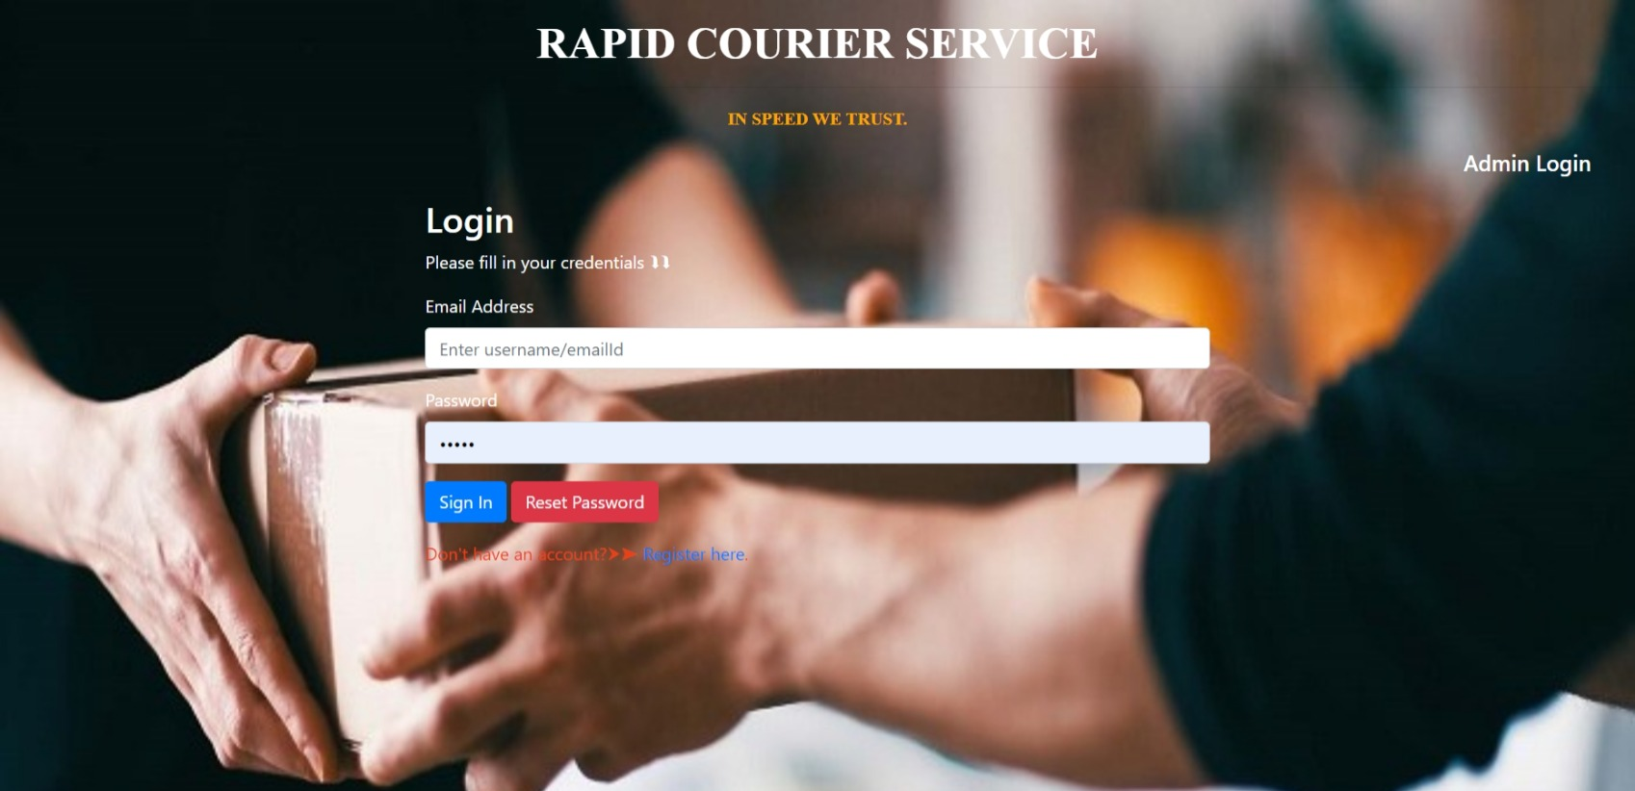**USER LOGIN PAGE**
2. 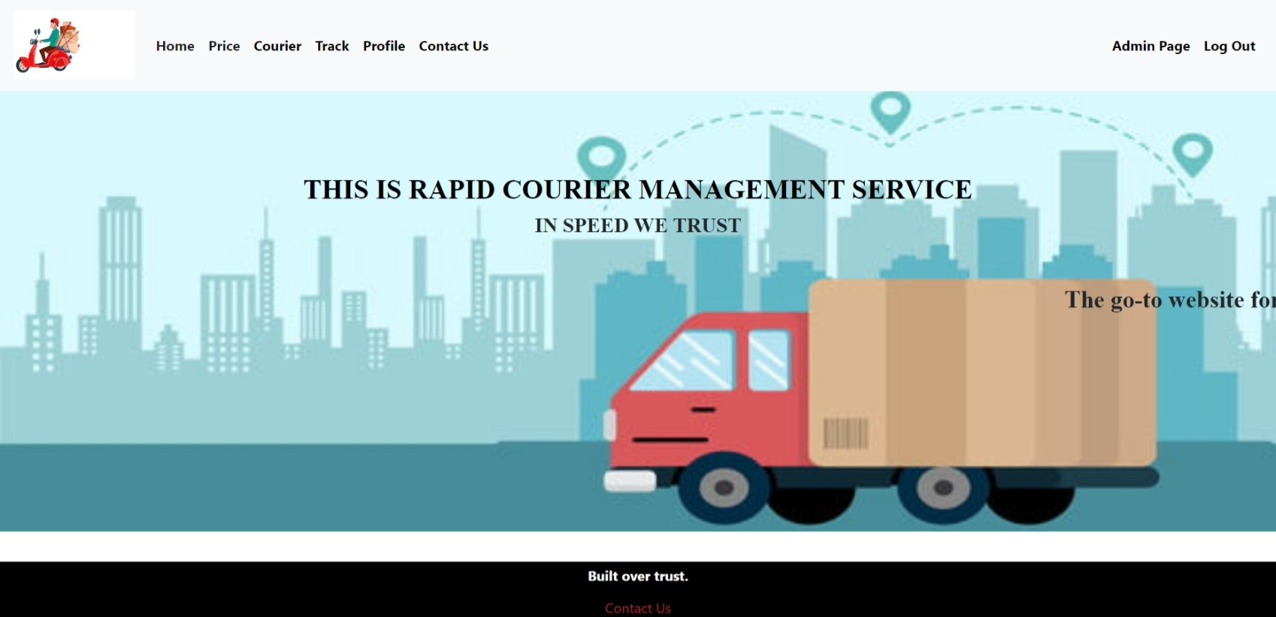**HOME PAGE**
3. 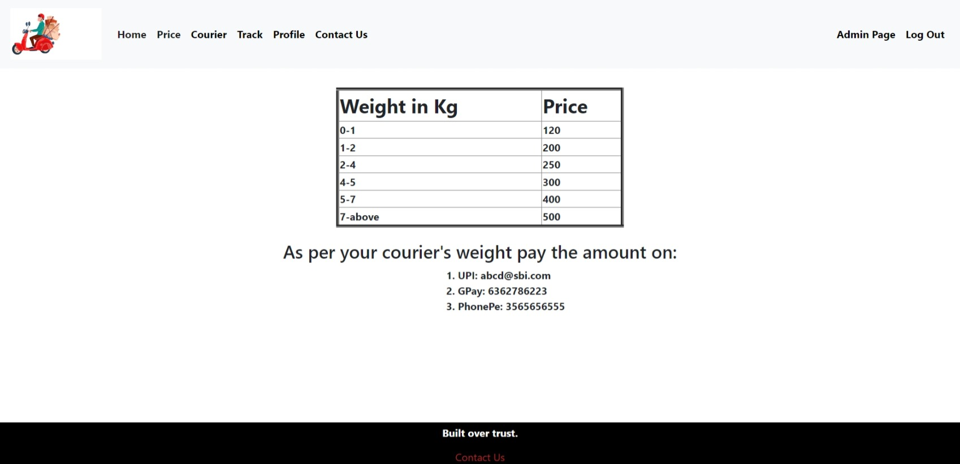**PRICING OF COURIER PAGE**
4. **COURIER SENDING PAGE**

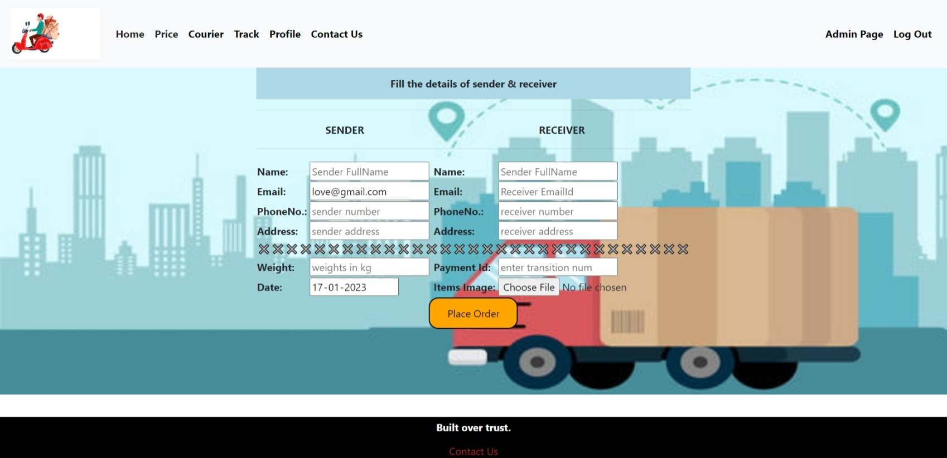

1. 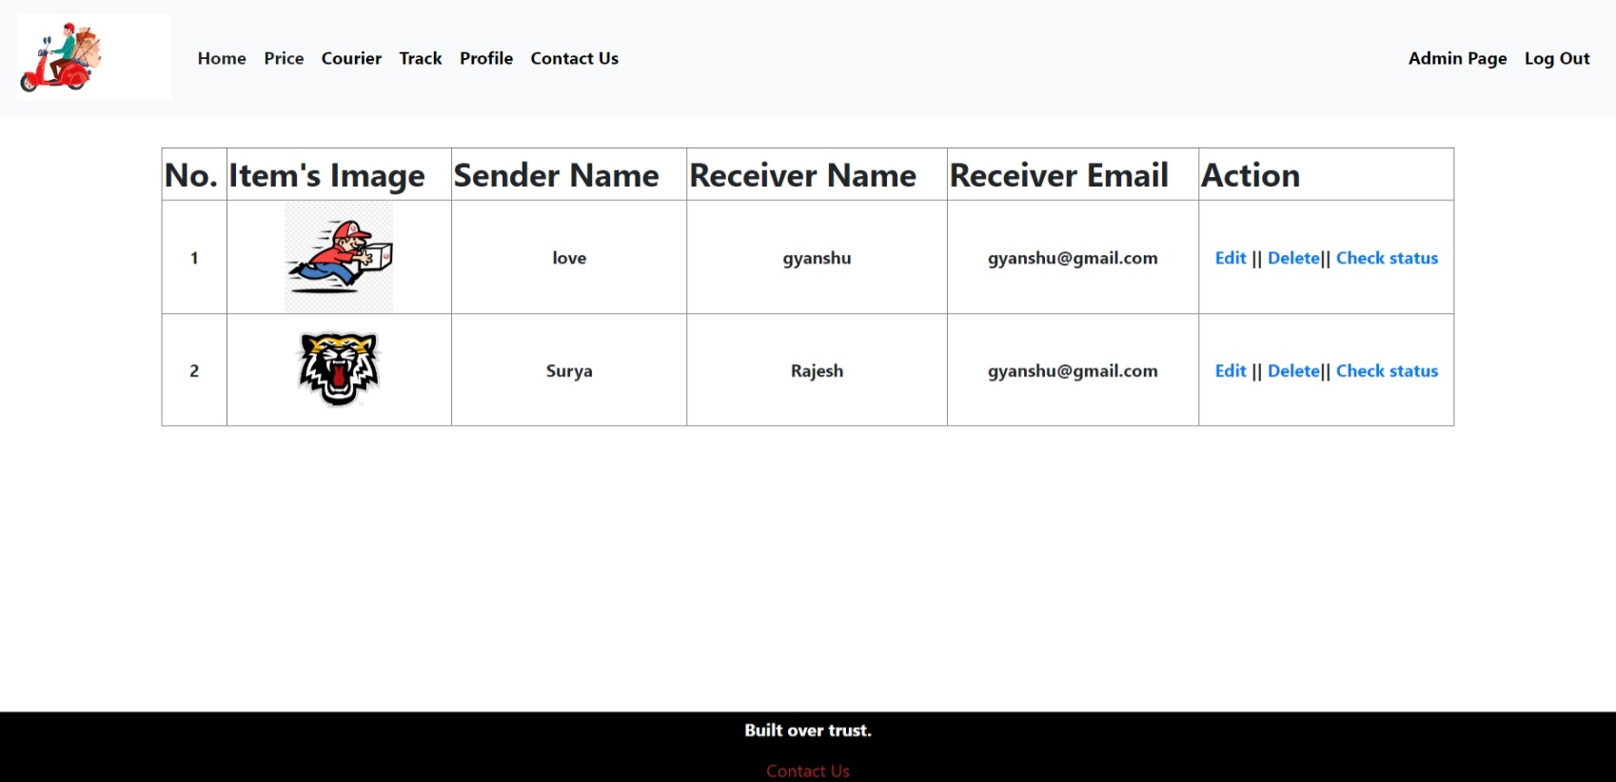**TRACKING PAGE**
2. 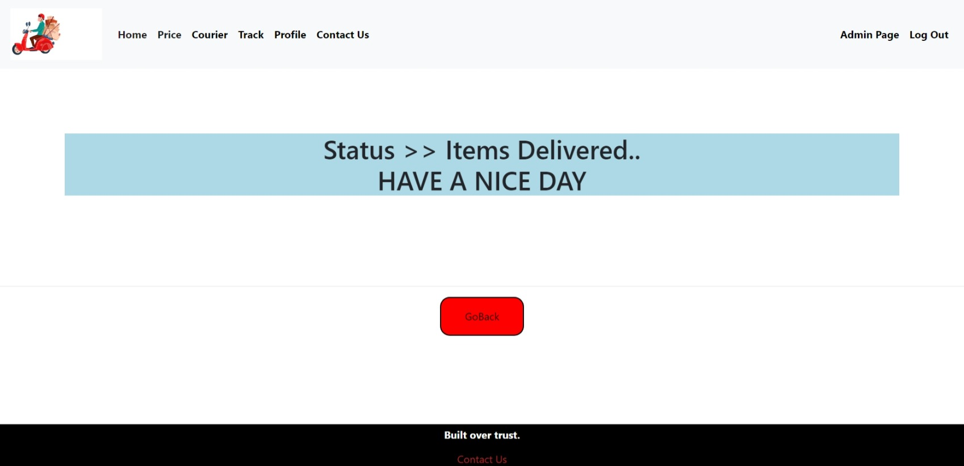**TRACK STATUS PAGE**
3. **PROFILE PAGE**

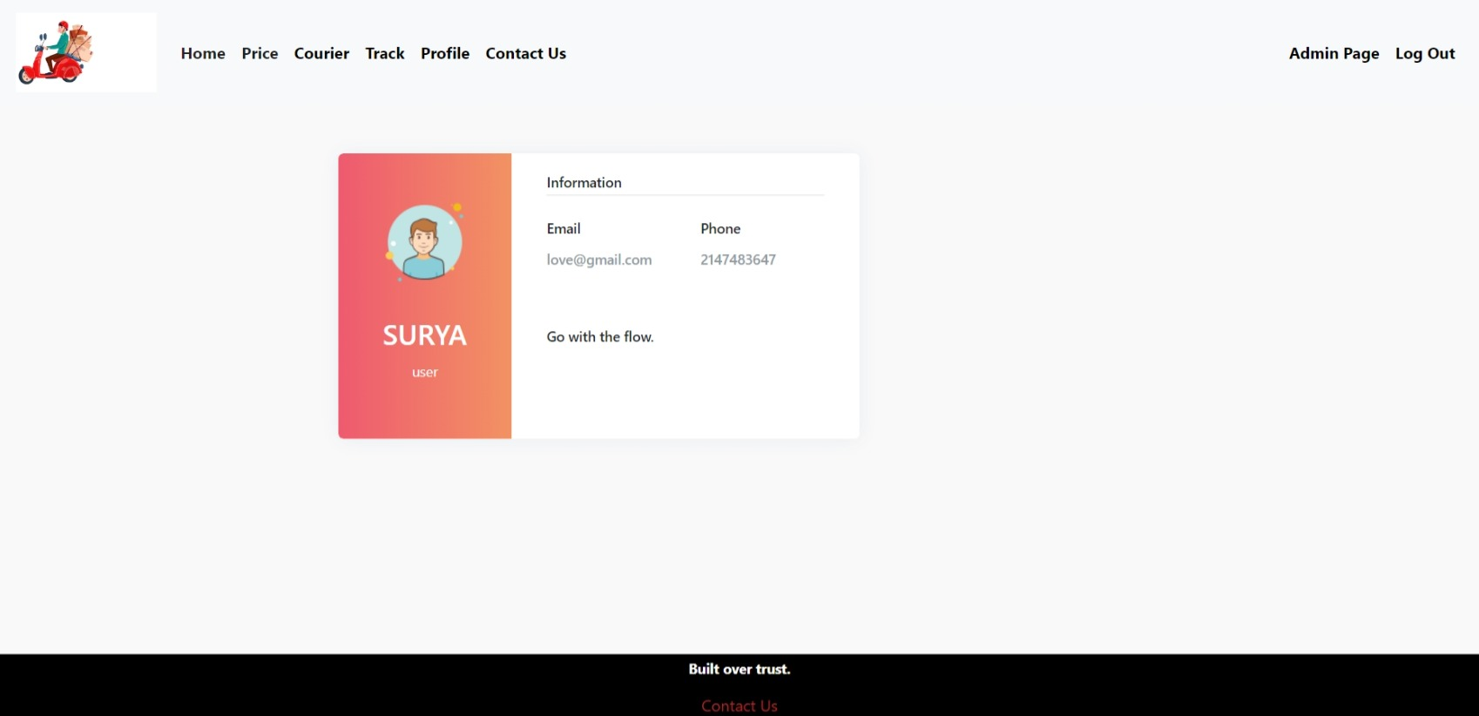

1. 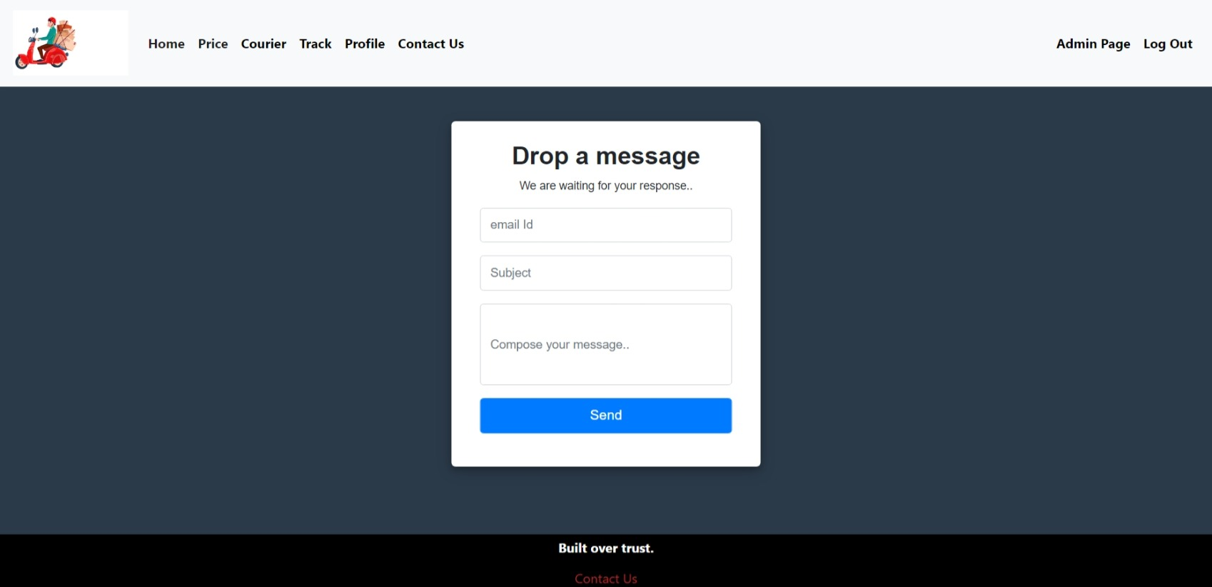**CONTACT US PAGE**
2. 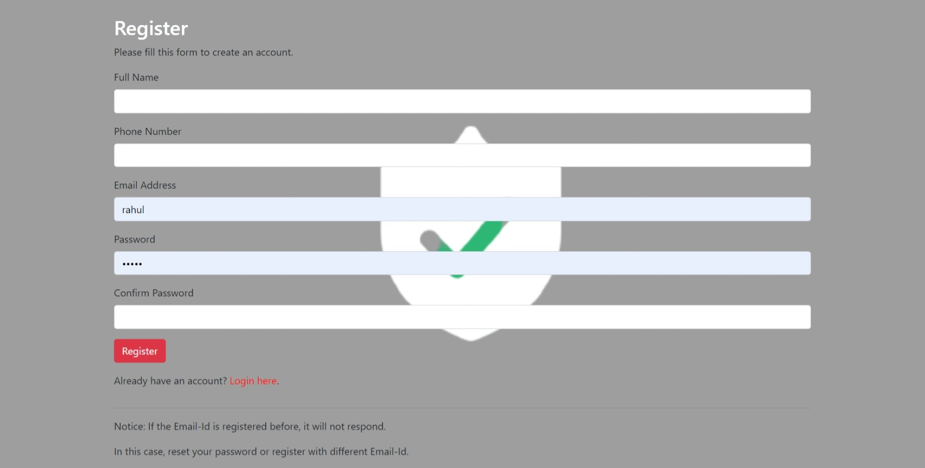**REGISTER NEW USER PAGE**

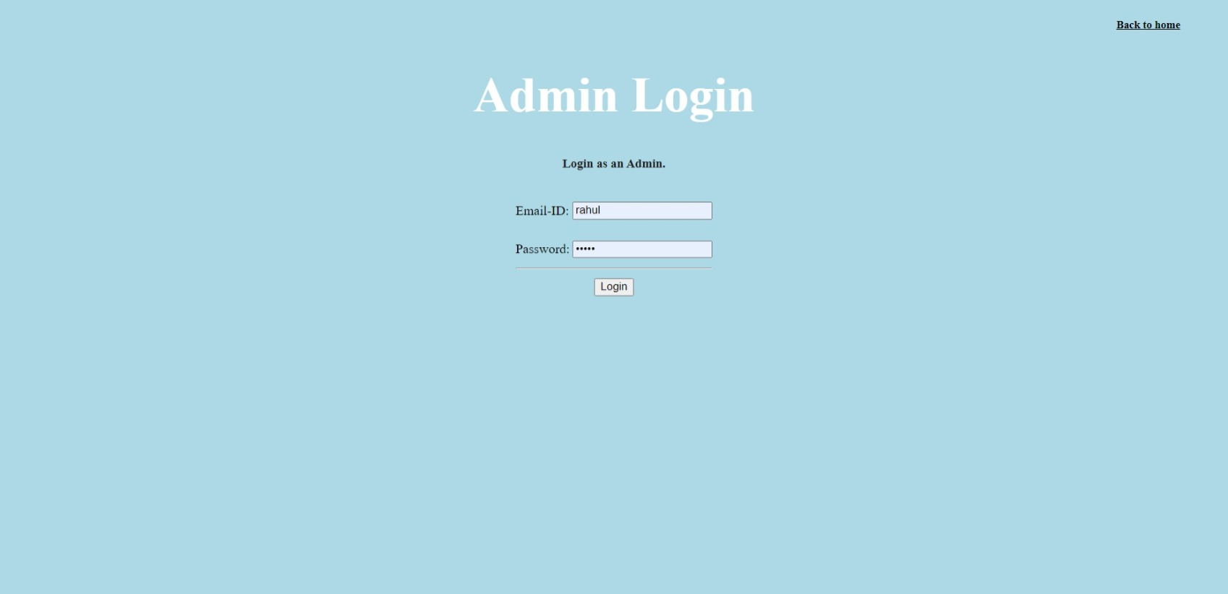**10. ADMIN LOGIN PAGE**

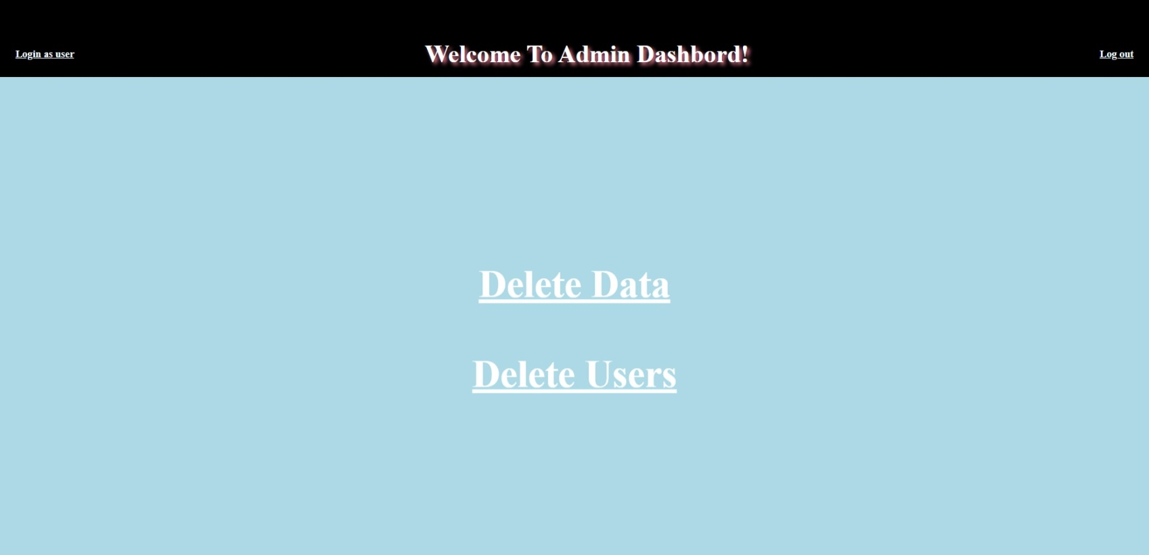**11. ADMIN DASHBOARD PAGE**

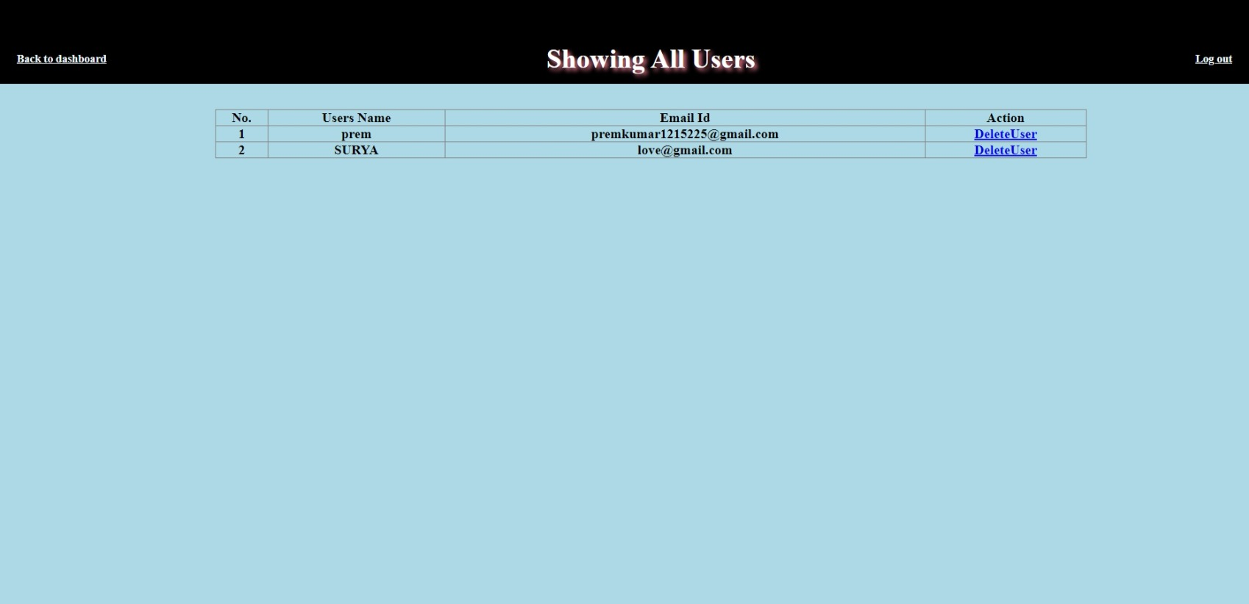**12. USER DETAILS PAGE**

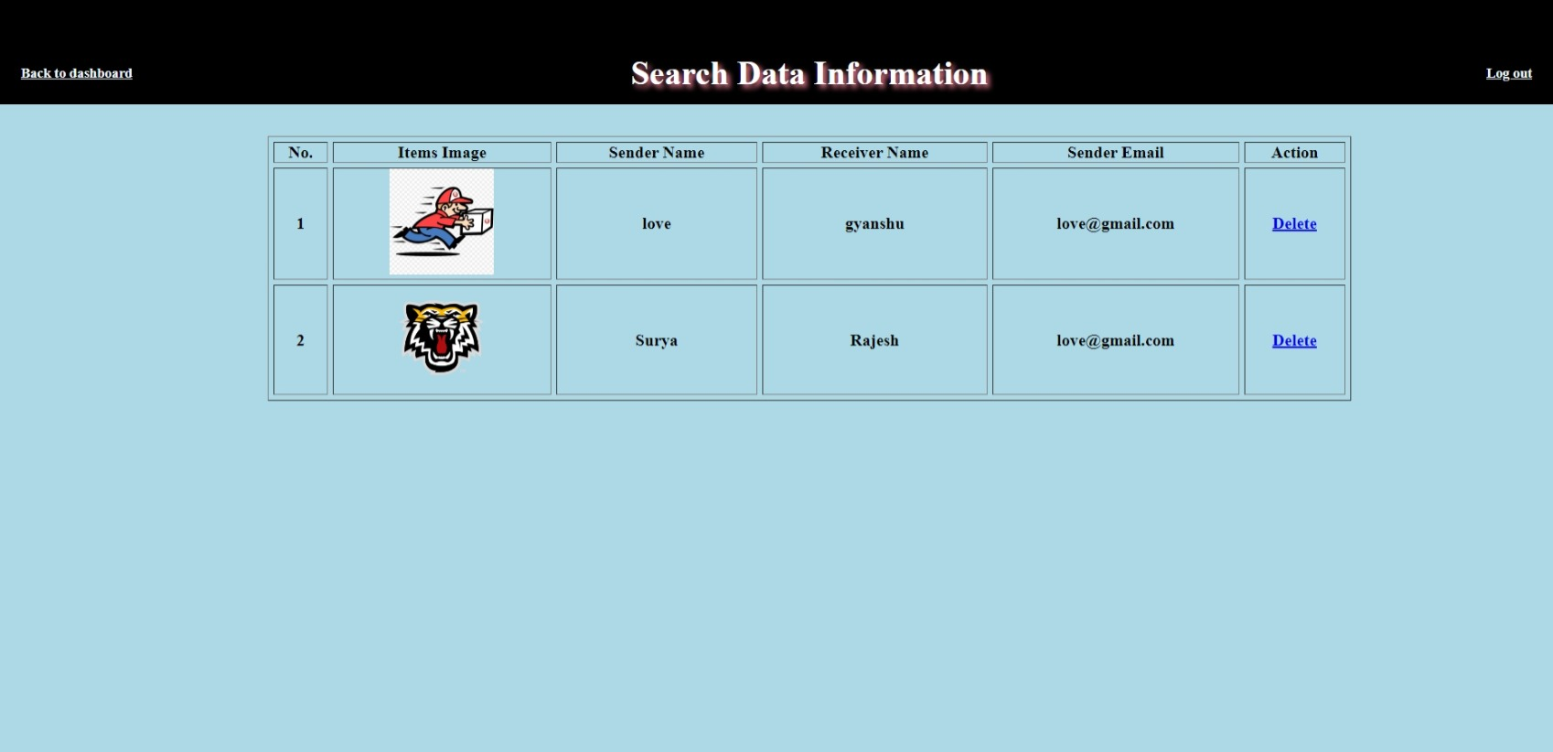**13. ADMIN DELETE DATA PAGE**

**14. UPDATE COURIER DETAILS PAGE**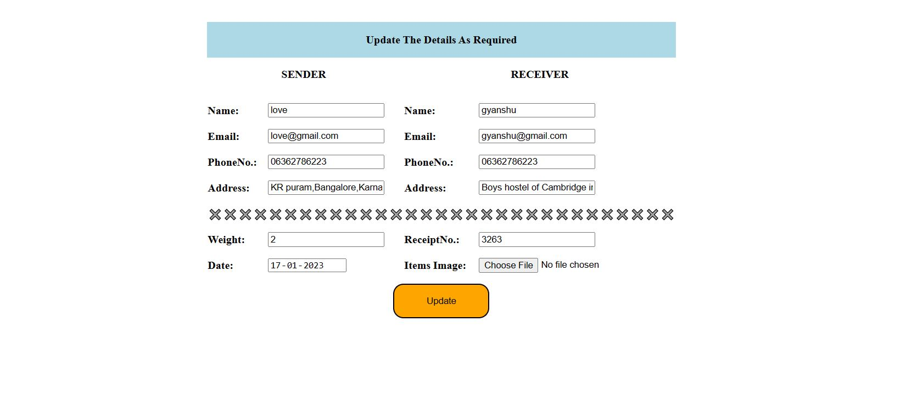

**15. DATABASE TABLES LIST**

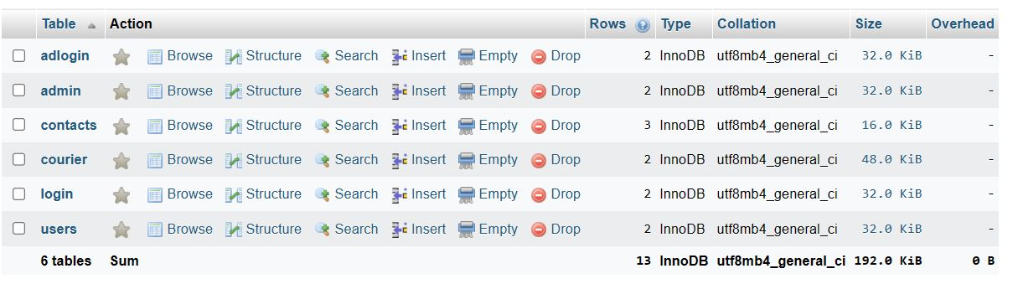

# CHAPTER 5

# CONCLUSION

Courier agency is considered as an expansion of business relations. It contributes a lot by providing quick & fast services of sending documents letters (formal & informal both) to business as it enables any business to flourish.

Following modification or upgrades can be done in system:

1. More than one company can be integrated through this software.
2. Web services can be used to know exact delivery status of packets.
3. Client can check the repacked delivery status online.

4) Distributed database approach in place of centralized approach.

# Features

These are the important features of the project Courier Management System:

• In computer system of the courier service computation of the rate is easily & quickly done.

• Computer system of the courier service provide fast access.

• Using this computerized system, bill issued procedure becomes fast.

• In computer system the person has to fill the various forms & number of copies of the forms can be easily generated at a time.

• In computer system, it is not necessary to create the manifest but we can directly print it, which saves our time.

• It contains better storage capacity.

• Accuracy in work.

• Easy & fast retrieval of information.

• Well-designed reports.

• Decrease the load of the person involve in existing manual system.

• Access of any information individually.

•Work becomes very speedy.

•Easy to update information.

# HADWARE AND SOFTWARE REQUIREMENTS

**Software Requirement:**

 Apache Server 2.0

 PHP Version 5.3 or above

 MySQL Version 5.5 or above

 Latest browser: Brave, Chrome, Firefox, Safari etc.

 Operating System: Any (Linux, Windows, Mac etc.)

**Hardware Requirements:**

 Processor Pentium IV or higher version.

 Ram 128 MB or above

 Hard Disk 150 MB or above.

**References**

• <http://www.bluedart.com/>

• <http://www.xamppserver.com/en/>

• <http://www.php.net/>

• <http://www.tutorialspoint.com/mysql/>